Isaac Simms – CS410 Fall 2026 – MP1

1. BM25 Parameter Exploration
Term/variable definitions:
Term k1 = term-frequency saturation. How much repeated instances of a term in the document raise the score. A large k1 means that more occurrences of a query term in the document raise the rank. A smaller k1 means that weight in the rank falls off faster.
Term b: document length normalization. Defines how much a document is penalized for its length, relative the average document length in the collection. A small b means there is no length penalty. A large b (close to 1.0) means that the document length is completely normalized.

Graph 1: k1 fixed at 0.9 with variable b values between 0-1.0
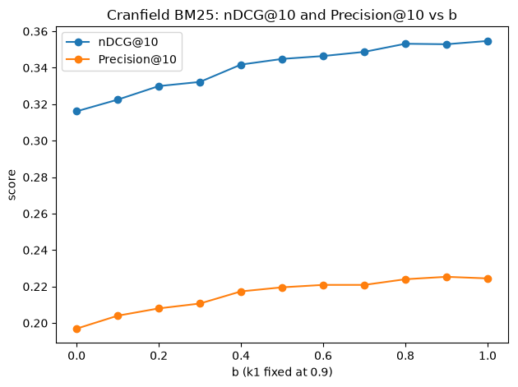

While b was equal to 0 there was no document penalty. While b was equal to 1 the term frequency was scaled in close association with how long the document is compared to average. Cranfield contains a large amount of scientific abstractions. As we look at the graph we will see an upward slope across both nDCG@10 and Precision@10. This tells us that the increased document normalization via b helped ranking the Cranfield dataset. Without that document normalization the longer scientific abstractions where collecting term matches which where not providing additional aid in determining if if the document was relevant to the query.

Graph 2: b is fixed at 0.4 with variable k1 values between 0-3.0
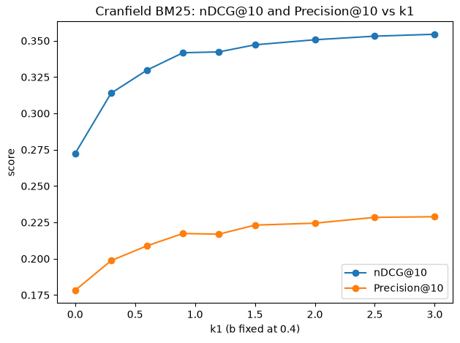

As the k1 value increases, we see a sharp increase in success as that value increases from approximately 0.0 to 0.5. As k1 continues to rise we continue to see slight improvements to ranking success totaling in a 0.082 inc4rease in nDCG@10 and a 0.051 increase in Precision@10. The sharp initial increase makes sense. If k1 = 0 then the presence of a term is not having any effect on the relevance ranking of a document, which is a poor measure of relevance. However, when a slight increase to k1 is added now any presence of a term has an effect on the relevance ranking. Which, term presence is a good gauge on a document’s relevance to a query. However, there is a point of diminishing returns where having even more instances of a term does not necessarily increase the likelihood a document is relevant. So, we are going to see the success of term frequency leveling off.

2. Algorithm Comparison
Algorithm 1: tfidf.py was built to

